DSD ASSIGNMENT -1

Ripple Carry Adder

16:1 MUX

Team members:

Akshat V.A.

Amogh S. Rao

C.P.Sindhu

**8 Bit Ripple carry adder**

Black Box Structure:

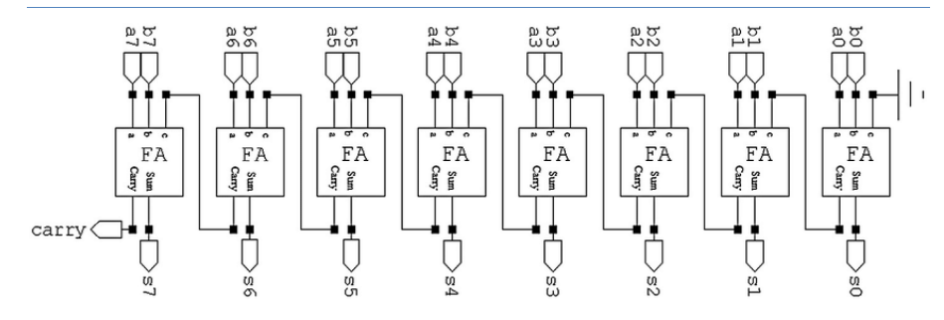

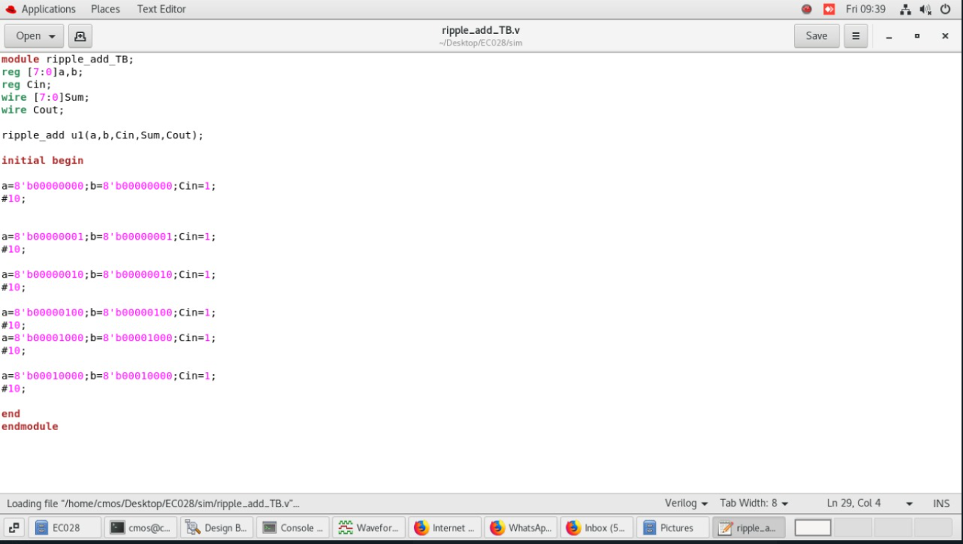

Inputs we tried for 8:1 RCA

Output:

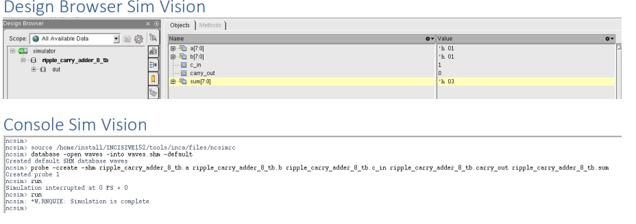

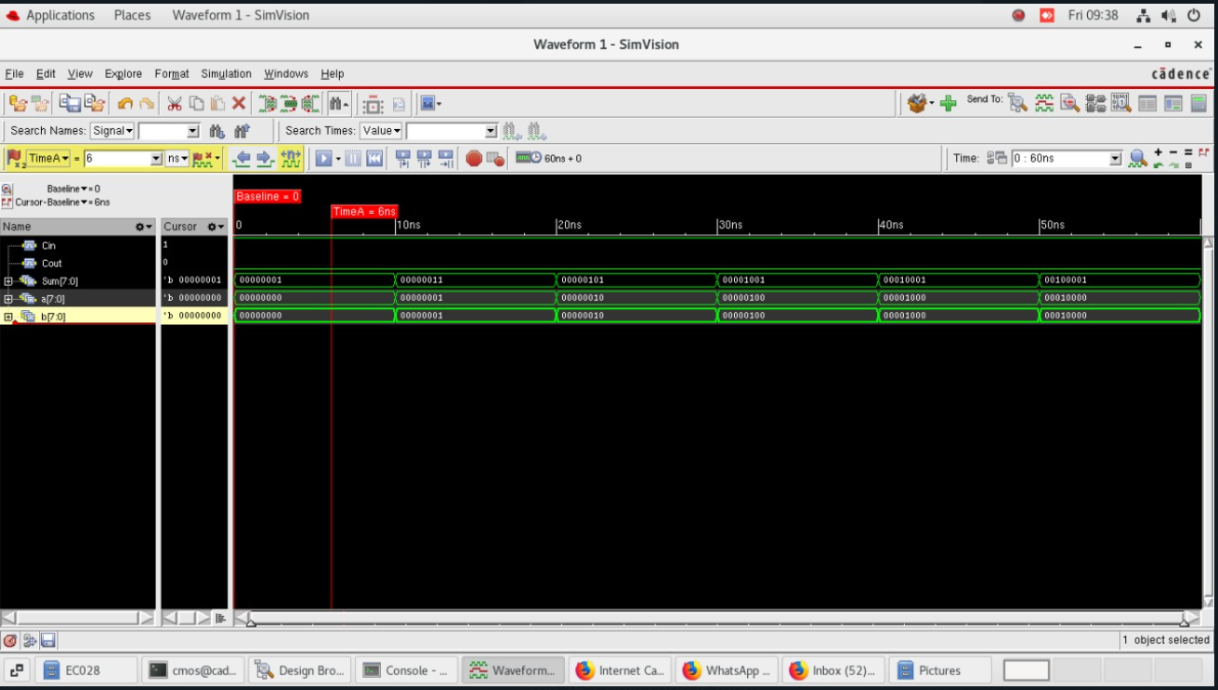

Using Cadence we successfully demonstrated an 8:1 ripple carry adder with the help of full adders.

**16:1 MUX:**

Black Box Structure:

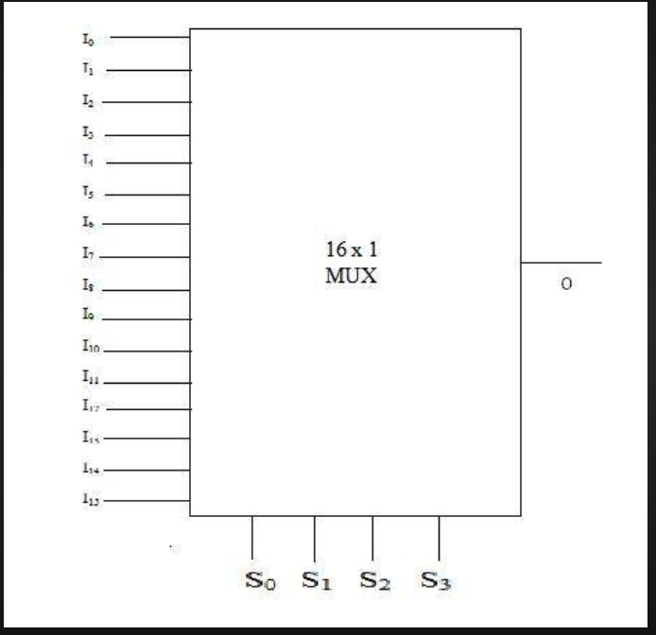

Inputs we tried for:

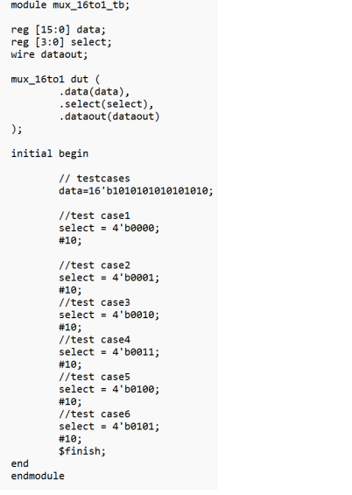

Output:

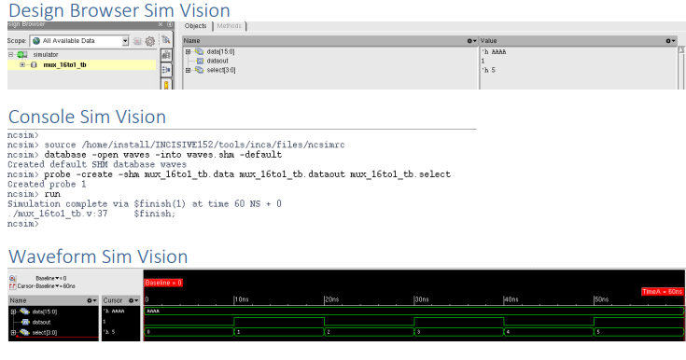

Using Cadence we successfully simulated 16:1 MUX using 4:1 and 2:1 MUXs.